An Accounting Application – Inventory Depreciation Calculator

Depreciation For tax purposes an item may be depreciated over a period of several years, *n*. With the *straight-line* method of depreciation, each year the item depreciates by (1/*n*)th of its original value. With the *double-declining-balance* method of depreciation, each year the item depreciates by (2/*n*)ths of its value at the beginning of that year. (In the final year it is depreciated by its value at the beginning of the year.) Write a program that performs the following tasks:

1. Request a description of the item, the year of purchase, the cost of the item, the number of years to be depreciated (estimated life), and the method of depreciation. The method of depreciation should be chosen by clicking on one of two buttons.
2. Display a year-by-year description of the depreciation.

DELIVERABLES

1. **A Structured Diagram of your Program such as below: Obviously yours will be much different**

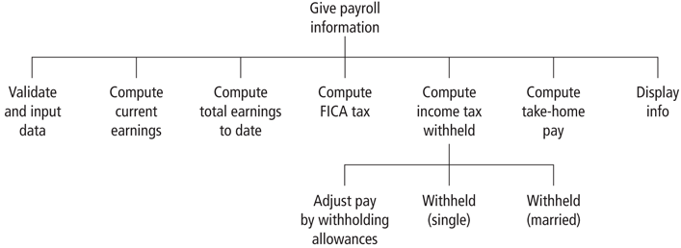

**2. Provide Pseudocode such as this example below**

**Pseudocode for the Depreciation Application**

VALIDATE data (Function TrueData)

Check depreciation method

COMPUTE depreciation rate (Function GetDepreciationRate)

INPUT depreciation data (Sub procedure ShowDepreciationResult)

OUTPUT depreciation info (Sub procedure ShowDepreciationResult)

OUTPUT basic info

OUTPUT each year depreciation info

**3. Provide an Object table per the sample below:**

| **Object** | **Property** | **Setting** |
| --- | --- | --- |
| frmDepreciation | Text | Depreciation |
| lblProduct | Text | Item |
|  |  |  |
|  |  |  |
|  |  |  |
|  |  |  |
|  |  |  |
|  |  |  |
|  |  |  |
|  |  |  |
|  |  |  |
|  |  |  |

**3. Provide a Table of Products and details as demonstrated below**

| **Product Name** | **Original Cost** | **Year of Purchase** | **Estimated Life of Product** | **Depreciation Type** |
| --- | --- | --- | --- | --- |
| Computer | $1,500 | 2015 | 5 | Straight line |
|  |  |  |  |  |
|  |  |  |  |  |
|  |  |  |  |  |

**4. Deliver 4 Printouts of your form. One for each of the Inputs above**

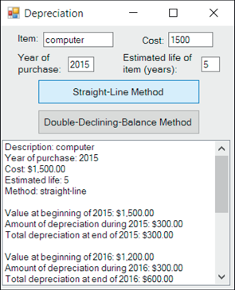

**4. Deliver A Printout of your Code**

**5. Coding Design**

1. **Must include at least one Subroutine, One Function (byvar or byref), and at least one loop**
2. **The loop will be required to depreciate and print each Value as in the output above**
3. **Naming conventions for all Objects must match your table above**
4. **Each button can run a different Subroutine (you can decide if this is necessary)**
5. **All Variables must be declared with data types and they must match the functions**
6. **All output should be formatted as seen above (Currency as Currency etcf)**
7. **Comments should be used to explain what variables are for if they are not self explanatory per ood naming conventions**
8. **All Subroutines and Functions must have proper names and use naming conventions (First letter is always capitalized and each new part capitalized also (CalcStraightlineDepreciation)**
9. **Comments above Subroutines and above loops etc explaining their purpose is good practice.**

**6. Other information**

* **Assignment can be worked on in teams of three. The name of the Word document should include your Section and Student names (English or Chinese) with a hyphen between each partner**
* **The Project folder should be zipped and uploaded also with your Assignment. Again, name it properly**
* **Each students name should be at the top of the Delivery document**
* **If students worked on different aspects of the project almost exclusively, then you should Identify that with your English name.**
* **Assignment will be uploaded on Monday 26, 2018 and due on Monday April 2nd at 17:00**
* **Unlimited submissions up to the deadline per team but the assignment will be taken down in the evening of the due date. No late assignments will be accepted.**

**7. Grading: 60 percent if project works using the 4 pieces of data you provide, 10% if your component names match the names provided in this documentation, 10% for proper naming of variables and comments, 10% for form design, and 10% on the correctness and appearance of the documentation provided**

**\*\*\*\*A flowchart of your project will give you a bonus of up to 10 points**

**Please assign a team leader. She/he should use their section and English name, and give me the 2 other names in the group. Send this to me on Monday. I will identify this as a group assignment and each Group will go by the leader’s name.**

**If this group will change for project 2 or Project 3 let me know. I would like the names and participants for each Final Project group by Tuesday the 27th of March. If at all possible please keep the group the same as for project 1**